Pharmacorner
GPAT TEST –I
- In the mixing of thymol and menthol the following type of incompatibility occurs :
(A) Chemical incompatibility
(B) Therapeutic incompatibility
(C) Physical incompatibility
(D) Tolerance incompatibility
- A positive Benedict’s test is not given by
(A) Sucrose
(B) Lactose
(C) Maltose
(D) Glucose
- Which drug is popularly known as Hit and Run Drug?
a.Digitalis
b.Reserpine
c.Amrinone
d.Hydralazine
- The applicability of Noyes-Whitney equation is to describe
(A) First order kinetics
(B) Zero order kinetics
(C) Mixed order kinetics
(D)Dissolution rate
- Cancer causing gene is
A) Proto-oncogene
B) Oncogene
C) Mutable gene
D) Transposon
- In the TCA cycle, at which of the following enzyme-catalyzed steps, incorporation of elements of water into
an intermediate of the cycle takes place :
(A) Citrate synthase
(B) Aconitase
(C) Maleate dehydrogenase
(D) Succinyl Co-A synthase
- Osazones are not formed with the
(A) Glucose
(B) Fructose
(C) Sucrose
(D) Lactose
- Drove's test used for
(A)Suspending agent
(C) Surfactant
(B) Wetting agent
(D) Disintegrant
- Which is not a secondmessenger?
A. Amp
b. Guanylcyclase
c. Dag
d. Ip3
- In human being XX - genotype is
A) always female
B) can be male or female
C) always male
D) commonly female with 5 per lakh being male
- Circular stomata is seen in
a.Gloriosa
b.Colchicine
c.Digitalis
d.Buchu
- A carbohydrate, known commonly asinvert sugar, is
(A) Fructose
(B) Sucrose
(C) Glucose
(D) Lactose
- A positive Seliwanoff’s test is obtainedwith
(A) Glucose
(B) Fructose
(C) Lactose
(D) Maltose
- which is following is not a reversible phenomenon?
a.glass transition
b.melting
c.crystallization
d.none
- A carbohydrate, commonly known asdextrose is
(A) Dextrin
(B) D-Fructose
(C) D-Glucose
(D) Glycogen
- Treatment with alloxan destroys
A) STH cells
B) ß - cells of islets of langerhans
C) Cells of sertoli
D) Cells of leydig
- Which one of the followingis used in therapy ofToxoplasmosis?
a. Artensunate
b. Thiacetazone
c. Ciprofloxacin
d. Pyrimethamine
- Chloroguanide is
a) A prodrug b) metabolited to cycloguanil c) Biguanide d) all of these
- Following is used in Hodgkin'sdisease
A)Mephalan
B)Peclitaxol
C)Estramustine
D)Mechlormethamine
- Hetrocyle present in pilocarpine is
a) Imidazole b) Pyrimidine c) Indole d) Purine
- In recent years DNA sequences mt-DNA & Y-chromosome were considered for study of human evolution because
A) Their structure is know in greater detail
B) They are unipaternal& don't undergo recombination
C) They are small & easy to study
D) They can be studied from samples of fossil remains
- DNA is associated with basic protein
A) Albumin
B) Actin
C) Histone
D) Globulin
- Which Antibiotic show D-Threo isomer a) Tetracycline b) Aminoglycoside c)Chloramphenicol d)BetaLactum
- Resting Cell Potential is
A)30-80 mV
C)0 to -10 mV
B) -30 to -80 mV
D)10-100 Mv
- A small baby have pneumonia & fever so to avoid toxicity which NSAID is nt given.
A PCM
B CELECOXIB
C ETOROLEC
D ASPIRIN
- What does lack refer to in lac operon
A) Lac insect
B) 1,00,000
C) Lactase
D) Lactose
- Temoxifen is
A. Only estrogen antagonist
B. Estrogen antagonist to breastand agonist to Uterus and bone
C. Estrogen agonist to breastand antagonist to Uterus andbone
D. Only estrogen agonist
- Following ergot alkaloids is employed in T/T of Migraine.
a) Ergometrine b) Ergotamine c) Ergocristine d) Ergocryptine
- Reserpine hydrolysis yields
a) Methyl reserpate, trimethoxy benzoic acid
b) Methyl reserpate, trimethyl benzoic acid
b) Methyl reserpate, trimethxycinnamic acid
c) Methyl reserpate, trimethylcinnamic acid
- One of the following is water-soluble ergot alkaloid
a) Ergometrine b) Ergotamine c) Ergocristine d) Ergocryptine
- Truxilline acid on hydrolysis yields
a) Ecogonine +Methanol + Benzoic acid b) Ecogonine + Methanol + Cinnamic acid
c) Ecogonine + Methanol + -Truxillic acid d) Ecogonine + Methanol + Tropic acid
- Which of the followingcephalosporin has disulfiramlike effect? (N)
(a) cefixime
(b) cefaperazone
(c) cefuroxime
(d)cefamandole
- Colchicines is derived from
a) Lysine b) Phenyl alanine c) Dihydroxyphenylamine d) Pyrosine
- Paparerine is derived from,
a) Lysine b) Ornithine c) Tyrosine d) Phenylalanine
- Which of the following is not lysine-derived alkaloid
a) Anabessine b) Lapinine c) Anaferine d) Colchicine
- One of the following is an example of pseudo-alkaloids
a) Atropine b) Anabessine c) Ephedrine d) Emetine
- Tropic acid portion in atropine is derived from
a) Proline b) Ornithine c) Phenyl alanine d) Lysine
- Cocaine on hydrolysis yields
a) Ecogonine +Methanol + Benzoic acid b) Ecogonine + Methanol + Cinnamic acid
c) Ecogonine + Methanol + -Truxillic acid d) Ecogonine + Methanol + Tropic acid
- Raowolfiaserpentina is distinguished from other species of Raowolfia by following microscopic character.
a) Sclerenchyma is absent
b) Narrow phloeum& consists of pavencyals with scattered sieve tissue
c) Parenchymatones secondary cortex &contain starch
d) All the above
- Ephedrine is derived from
a) Lysine b) Ornithine c) Tyrosine d) Phenylalanine
- One of the following is not indole alkaloid
a) Ergotamine b) Strychnine c) Yohimbine d) Piperine
- Oculogyric crisis is knownto be produced by all of thefollowing drugs except
a. Trifluoperazine
b. Atropine
c. Perchlorperazine
d. Perphenazine
- The best medium for production of penicillin is
a. Nutrient Agar
b. Corn steep liquor
c. Sulfite waste liquor
d. Whey
- st.anton's fire is associated with...?
a)reserpine b)clonidine c)ergot d)yohimbine
- the bacterial spores are destroyed by
a)Dessicstion
b)Phenol
c)Boilling
d)Autoclaving
- the immunoglobin which crosses placenta is
a) 1gA
b)1gD
c)1gG
d)1Gm
- which of the following is not a methyl xanthines derivative
a. theobromine
b. theophihylline
c. cocaine
d. caffine
- Taillingeffect in columnchromatography reduce by _________elution technique.
A.Isocratic elution
B.Fractional elution
C.Gradient elution
D.None of the above
- Dry mouth duringantidepressant therapy iscaused by blockade of
a. Muscarinic acetylcholinereceptors
b. Serotonergic receptors
c. Dopaminergic receptors
d. GABA receptors
- Which one of the followingdrugs increases gastrointestinalmotility?
a. Glycopyrrolate
b. Atropine
c. Neostigmine
d. Fentanyl
- Intrinsic activity found inexcept
A.Agonist
B.Inverse Agonist
C.Parial agonist
D.Antagonist
- Atropine does nt inhibit wchsecretn?
a.saliva
b.bile
c.tear
d.gi secretn
- ‎............ is not a chelating agent
a)ethylene diamine
b)tripyridyl
c)EDTA
d)citric acid
- Oral bioavailability of griseofulvin is increased by
A.Micronization
B.Solid dispersion
C.Amorphous generation
D.None
- ROTOSORT capsule sorting machine has max. handling of ..............capsules/hr?
a.1500
b.15000
c.150000
d.100000
- All of the following hormoneshave cell surface receptorsexcept
a. Adrenaline
b. GH
c. Insulin
d. Thyroxine
- Bancroft rule is related with
a. Solutions
b. Suspensions
c. Emulsions
d. Suppositories
- In lyophilized sterilepowders Trishydroxymethylamino methane is used as ______
A) Buffer
B) bulking agents
C) Protectant
D) None of the above
- Defect in philiadephia
chromosomes lead to
A.Leukaemia
B.Anaemia
C.Thrombocytosis
D.Lymphocytosis
- Which company is launching generic version of lipitor in india after pfizer lost it patentship on november 30,2011 in USA?
a. Glaxosmith
b. Cadila
c. Ranbaxy
d.Dr.Reddys
- Sulfonamides are metabolised by humans principally by
A. Acetylation
B. Deamination
C. Oxidation
D. Conjugation
- Rotation of electrons about the proton generates a secondary magnetic field which may oppose the applied field the, the proton is said to be
A.shielded
B.shifted
C.deshielded
D.bonded
- The chemical shift in NMR is expressed in
A.parts per million
B.gauss
C.tesla
D.hertz
- Saturable transport systems?
a)passive diffusion
B) aqueous diffusion
C) lipid diffusion
D) active transport -- carrier mediated
- which of the following is a diuretic steroid
a.acetazolamide
b.furosemide
c.spiranolactone
d.both a & c
- Gossypol is............
a)Hormone b) Pigment c)Enzyme d)All of these
- the solubility of the drug will be high when it in its
a) stable form
b)metastable form
c)unstable form
d) all of the above
- angle of repose of given powder is between 30-40 degree the type of flo is
a) excellent
b) good
c) passable
d) very poor
- which of the following is an active from of cocaine
a) Ecgonine
b)Tropococaine
c)Atropine
d)Pseudo cocaine
- In IR radiation source, globar is chemically
a.silicon carbide
b.silicon disulfide
c.zirconium oxide
d.thorium
- The deflection of positive ions formed in a mass spectrometer by electric and magnetic field depends upon its
a.mass
b.velocity
c.charge
d.all of the above
- The most intense peak in mass spectrum is known as
a.base peak
b.metastable peak
c.rearrangement peak
d.molecular ion peak
- A compound will be sensitive towards IR radiations only when one of the following properties undergo transition
a.polarisability
b.Dielectric constant
c.dipole moment
d.refractivity
- Widely used recorder in mass spectrophotometer is
a.thermocouple
b.galvanometer
c.photomultiplier tube
d,photocell
- Munsell system is associated with?
a,odor
b.flavor
c.color
d.chemical classification
- reagent gas used in chemical ionisation
a.methane
b.isobutane
c.ammonia
d.all the above
- the molecular weight of compound in mass spectrum is
a.highest m/e value in mass spectrum
b.lowest m/e value in mass spectrum
c.the intensity which is equal to 100%
- The characteristic odour of garlic is due to
A) a chloro compound
B) a sulphur compound
C) a fluorine compound
D) acetic acid
- the product of fragmentation in mass spectroscopy
a.may be radical cation
b.may be cation
c.may be radical
d.all the above
- Imipenem is inactivated by dehydropeptidase in renal tubules and belongs to class
a) Penicillin b) Cephalosporine c) Monobactum d) Carbapenem
- Which electronic transition requires maximum energy?
A) pie-pie*
B) n-pie*
C) sigma-sigma*
D) n-n*
- The digitalis action is enhanced by
a)sodium b)calcium c)magnesium d)potassium e)chloride
- limoneneis synthesized from?
a. terpeniol
b.citral
c.ionone
d.dipentene
- PEG 4000 monostearate is not miscible with?
a. Water
b. Alcohol
c. Ether
d. Benzene
- Betadine contains?
a.benzocaine
b.surfacaine
c.povidone iodine complex
d.gentian violet
- Lente insulin is?
a.givn only iv
b.another name for NPH insulin
c.70percent crystalline, 30percent amorphous
d. 70percent amorphous, 30 percent crystalline
- Rhubarb contain ______ type of glycoside
A. C-Glycoside
B. O-Glycoside
C. S-Glycoside
D. N-Glycoside
- which drug has pappilose cells?
a.cocaleaf
b.punarnava
c.shankhpushpi
d.digitalis
- A mosquito repellent volatile oil is obtained from
a) Artemisia brevifolia b) Cymbopogonnardus c) Trachyspermumammi d) Cymbopogonflexuosus
- which of d these should not be administered to a patient with myasthenia gravis? a)physostigmine b)digitalis c)atropine d)curare
- The metabolic function of riboflavin involves ?
a.FMN and FAD
b. NADP and NADPH
c. AMP and ATP
d. Retin and retinine
- Which water is used 4 hand washing in change room of p'ceutical manufacturing plant?
A Potable
B Purified
C Disinfectant
D Soap
- A metabolite of spironolactone?
a. Pregnenolone
b. Corticosterone
c. Canrenone
d. Aldosterone
- wich of d following is neurotoxin
a-tetanus
b-vibrio
c-tubercullin
d-tetanospasmin
- klung test is for
a-aloesin
b-isobarbaloin
c-barbaloin
d-aloe-emodin
- idioblast r present in ?
a- cinchona
b-coca
c-hyoscyamus
d- all
- Who is new owner of piramal healthcare?
a. Adobbt
b. Pfizer
c. Glaxosmith
d.Merck
- Which f d fllwing antidepressant is safe in overdose?
A. Venlafaxine
B. Trazodone
C. Reboxetine
D. All the above
- Digeorage's syndrome is a?
a. Related to males ,characterized by failure of conversion of b-lymphocytes into antibody producing plasma cells
b.failure of thymus to develop diminished T cell response
c. All the above
d. None of the above
- If I have a cold, food may not taste as good to me because
A) The nerve fibrils are not functioning properly
B) My food will taste the same; taste and smell have nothing in common
C) Papilla become blocked by mucus and are unable to function
D) Olfaction, taste and trigeminal receptors together contribute to the flavor of my food
- The function of the Ileum is
A) Absorb nutrients
B) Absorb vitamin B12 and bile salts
C) To introduce bile and pancreatic juices
D) Absorb alcohol and aspirin
102.Whichp'ceutical company will be launching vaccine against maleria by 2015 ?
a.Novartis
b. Glaxosmith
c. Genetech
d. Plastuertech
103.
Which of the following compounds is represented by this infrared spectrum?
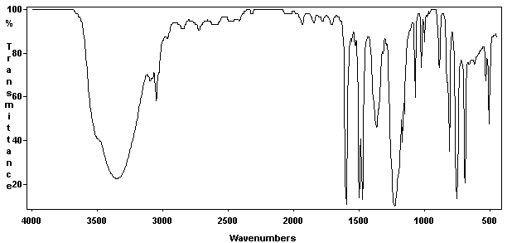
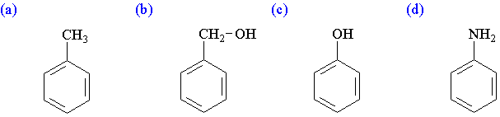

104.
What is the major product of the following reaction?
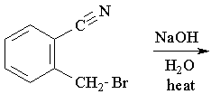
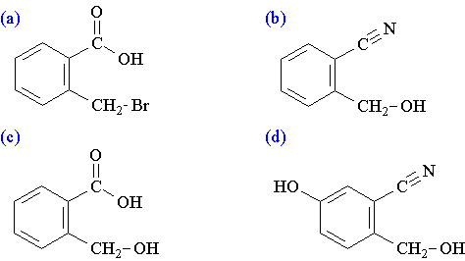
105.
Which of the following transitions is the highest energy transition?
 | (a) | n to s*
 | (b) | n to p*
 | (c) | s to s*
 | (d) | p to p*
106.
Which of the following alkenes would have the largest l_{max}?
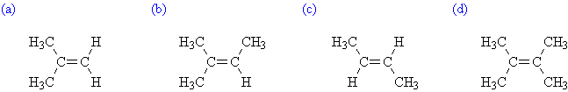
107. tyndalisation means :
A. Successive autoclaving with a bactericide
B. Succevive heating with a bactericide
C. Succevive heating at low temp
D. Successive autoclaving at low temp andincubation
108. flash point test apparatus
a)tag open cup
b)pycno meter
c)thiels tube
d)both b and c
109. BRIZ 35 is
A)polyoxyethelenelouryl ether
B) polyoxyethelenesorbitanmomolaurate
C) ) polyoxyethelenemonostearate
D)tween 20
110. Whch of the following dosage forms exhibit faster rate of reaction under normal condition ?
a.) emulsions
b.) ointments
c.) solution
d.) suspension
111.what is the role of IP4 Formed from IP3 during PI cycle-
(a) Absolutely faccillateCa++ ion entry via plasma membrane
(b) unclear but may faccillateCa++ ion entry via plasma membrane
(c) Activate PKa
(d) Inactivate Pka
112.
What is the l_{max} for the following compound? Use the above parameters for your calculation.
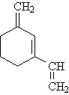
 | (a) | 229 nm
 | (b) | 249 nm
 | (c) | 254 nm
 | (d) | 259 nm

113.
Which of the following is an intermediate for the basic hydrolysis of methyl ethanoate?
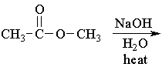
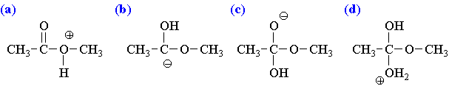
114. Red shift is also known as
a. Bathochromic shift b. Hypsochromic shift
c. Hyperchromic shift d. Hypochromic shift
115. Cyclohexane gives which type of band
a. K-Band b. R-Band
c. B-Band d. None of the above
116. In PMT the difference in energy levels between two consecutive dynodes is
a. 30 ev b. 70 ev
c. 50 ev d. 15 ev
117. The absorbance(A) equals to
a. It/Io b. Io/It
c. Log It/Io d. Log Io/It
118. The material used to prepare the dynodes used in the PMT is
a. Be-Cu b. Ba-Mg
c. Na-K d. Ag-Mn
119. In fluorimetry which of the following causes increase in the fluorescence
a. Oxygen b. Photochemical changes
c. Increase in temperature d. Increase in the viscosity
120. The source used in the fluorimetry is
a. Hg Vapour lamp b. Carbon arc lamp
c. Tunsten filament lamp d. Globar source
121. The property of bleeding out is shown by?
a.Suspensions
b.Ointments
c.Gels
d.Suppositories
122.ototoxicity n nephrotoxicity r common side effect of?
A. macroloides
B. polenes antibiotic
C. tetracycline
D.aminoglycoside antibiotics
123. In tablet copession machine the size and shape of tablet is dictated by
a. Punches& dies b. Feed frame
c. Camtracks d. Sliding chute
124.chief constituent of orange peel is
A.limonene
B.citral
C.cineole
D.geraniol
125. which is the main side effect of penicillin?
A. hypersensitivity
B.diarrhoea
C.nephrotixicity
D.skinrashes
126. Gingkgobiloba is used for its
(A) Expectorant activity (B) Lipid lowering activity
(C) PAF antagonistic activity (D)Antidepressant activity
127. The plunger used in the evaluation of the gelatin used for the capsule manufacture have the dimensions of
a. ½ inch diameter b. 1½ inch diameter
c. 1½ mm diameter d. ¾ cm diameter
128. Cardiac glycosides have the following configuration in the aglycone part of the steroid nucleus :
(A) 5a, 1 4 a - 5a, 14β- (C) 5β, 1 4 a - (D) 5β,14β-
129. The amount of barbaloin present in Aloe verais
(A) <1% (B) 3.5-4% (c) 1-1.5% (D) 2-2.5%
130.
Which of the following compounds is the strongest Brønsted base?
 | (a) | CH₄
 | (b) | NH₃
 | (c) | H₂O
 | (d) | HF

131.
What is the major product obtained from the following reaction?
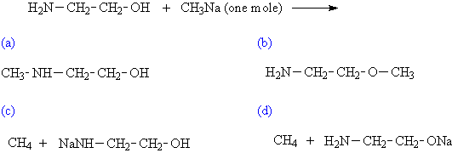

132.
Which of the following compounds is the strongest Brønsted base?
 | (a) | H₂PO₄⁻
 | (b) | HSO₄⁻
 | (c) | NO₃⁻
 | (d) | CH₃COO⁻
133.
What is the major product of the following reaction?
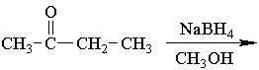
 | (a) | S-2-butanol
 | (b) | R-2-butanol
 | (c) | a racemic mixture of 2-butanol
 | (d) | the hemiketal of 2-butanone and methanol...2-hydroxy-2-methoxybutane
134.
Which of the Fischer projections correctly depicts the following compound?
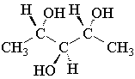
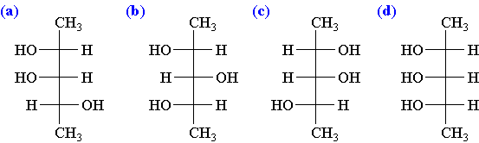
135. tabletsshldhavatlst ___________ years of expiartn date
a.2
b.1
c.2.5
d.1.5
136. According to Lemke rule of drug solubility in water propanol is soluble in how many parts of water?
a.<1 part
b.100-1000 parts
c.1-10 parts
d.10-30 parts
137. DOC for Erythmatusnodosumleprosum?
a.Dapsone
b.Clofamazine
c.Isoniazid
d.Thallidomide
138. Which of the following is the tablet hardness tester
a. Strong cobb tester b. Erweka tester
c. Schleuniger tester d. All the above
139. The starting material for synthesis of chloroquine is?
A.m-chloro aniline
B.p-chloroaniline
C.o-chloroaniline
D.o,pdichloroaniline
140. fujikorai and karpus test are usedfor detection of which disease?
a.cancer
b.HIV
c.TB
d.angina
141. The active metabolite of spironolactone is
a. Indacrinone b. Canrenone
c. Triamterene d. All the above
142. The phenomenon of package "breathing" is a major cause of product deterioration during storage in _________?
A. Glass container
B. Plastic container
C. Metal container
D. None
143. The phenomenon of package "breathing" is a major cause of product deterioration during storage in _________?
A. Glass container
B. Plastic container
C. Metal container
D. None
144. The correct order of reactivity of the following is?
a.Benzene>Napthalene>Anthracene
b.Anthracene>Napthalene>Benzene
c.Napthalene>Benzene>Anthracene
d.Benzene=Napthalene=Anthracene
145. Radiation is the final step of sterilization method of which of the following dosage form?
a.Suspension
b.Tablet
c.Elixirs
d.Ointments
146. One of the following drug is TRIVIAL named nomenclature?
a.Salicylic acid
b.Paracetamol
c.Ibuprofen
d.Diclofenac
147. immunophils is use in arthritis?
a.tacrolimus
b.cyclossporin
c.sirolimus
d.cyclophosphamide
148. Polyuronic acids are the salts of
a) Sod & calcium b) Calcium & magnesium c) Sodium & Magnesium d) Potasium& Calcium
149. musk oil is obtained from
A.abelmoschosmoschatus
B.castor fiber
C.moschusmoschiferus
D.viuerrazibetha
150. ‎__is a potassium channel opener as well as nitric oxide donor.
a) Diazoxideb) Cromakallinc) Minoxidild) Nicorandil

GPAT TEST–I ANS.
1-C | 26-D | 51-D | 76-D | 101-B | 126-C
2-A | 27-B | 52-B | 77-A | 102-A | 127-C
3-B | 28-B | 53-B | 78-B | 103-C | 128-D
4-D | 29-A | 54-A | 79-D | 104-C | 129-B
5-B | 30-A | 55-C | 80-D | 105-C | 130-B
6-B | 31-C | 56-B | 81-C | 106-D | 131-D
7-C | 32-B | 57-C | 82-B | 107-C | 132-D
8-B | 33-C | 58-C | 83-A | 108-A | 133-C
9-B | 34-C | 59-D | 84-A | 109-A | 134-D
10-D | 35-D | 60-C | 85-C | 110-C | 135-A
11-B | 36-C | 61-A | 86-C | 111-B | 136-D
12-B | 37-C | 62-A | 87-B | 112-D | 137-D
13-B | 38-A | 63-A | 88-A | 113-C | 138-D
14-D | 39-A | 64-D | 89-B | 114-A | 139-A
15-C | 40-D | 65-C | 90-A | 115-D | 140-A
16-D | 41-D | 66-B | 91-A | 116-B | 141-B
17-D | 42-B | 67-B | 92-A | 117-D | 142-B
18-D | 43-B | 68-C | 93-C | 118-A | 143-C
19-A | 44-C | 69-D | 94-A | 119-D | 144-B
20-D | 45-D | 70-A | 95-B | 120-A | 145-D
21-B | 46-c | 71-D | 96-D | 121-D | 146-A
22-C | 47-c | 72-A | 97-A | 122-D | 147-A
23-C | 48-A | 73-C | 98-D | 123-A | 148-B
24-B | 49-A | 74-C | 99-B | 124-A | 149-C
25-D | 50-C | 75-C | 100-D | 125-A | 150-D

